**MongoDB Database - the Product Order database.**

1. Open VS Code and connect to MONGODB

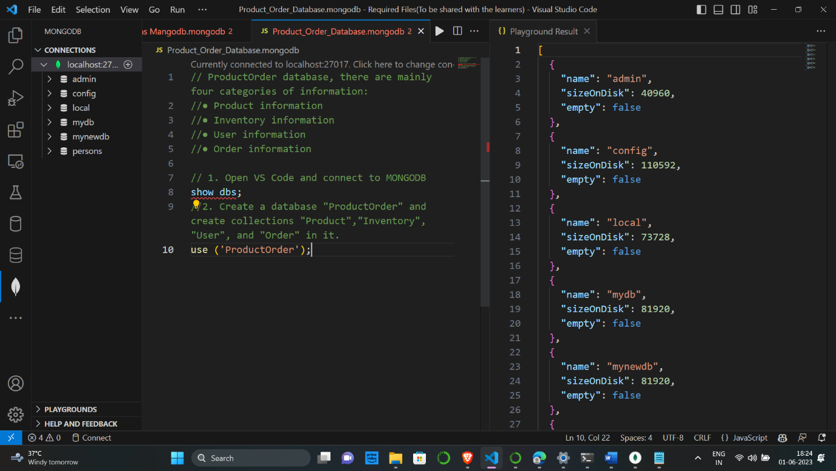

1. Create a database "ProductOrder" and create collections "Product", "Inventory”, "User", and "Order" in it.

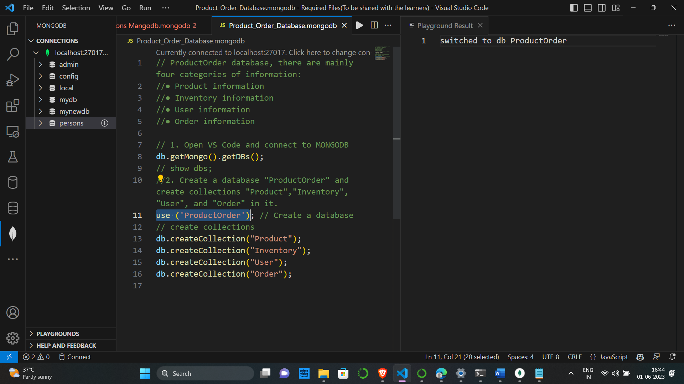

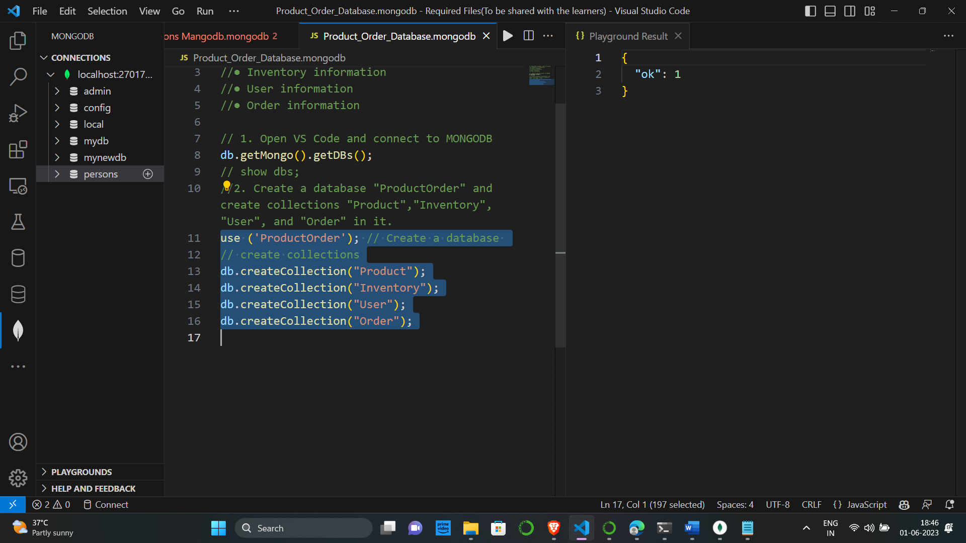

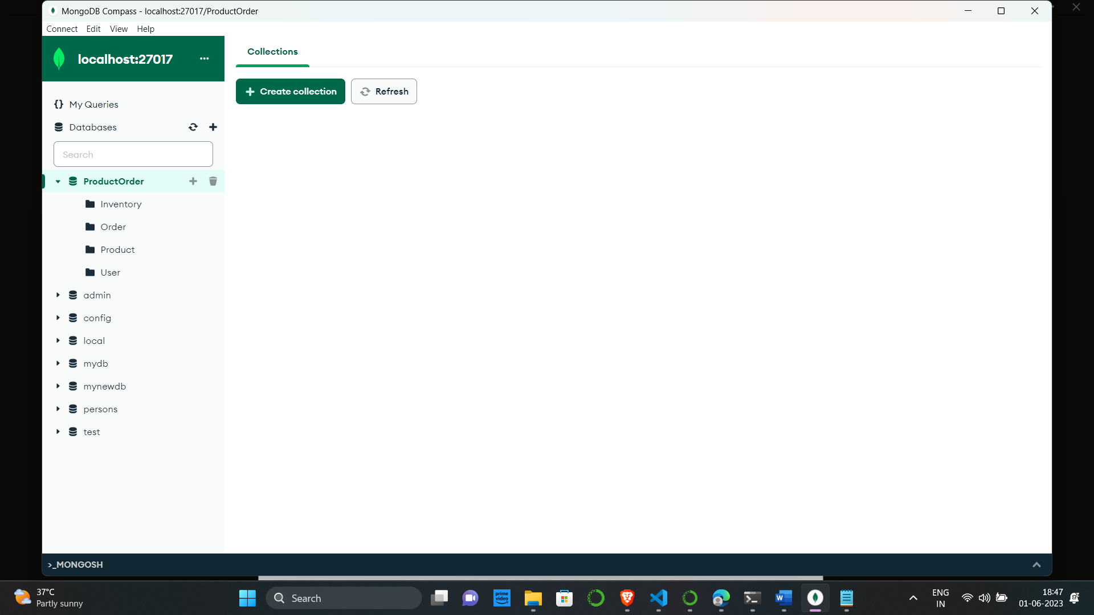

3. Open MongoDBCompass and navigate to the "ProductOrder" database.

i) Add "Product_info.json" file into the "Product" collection.

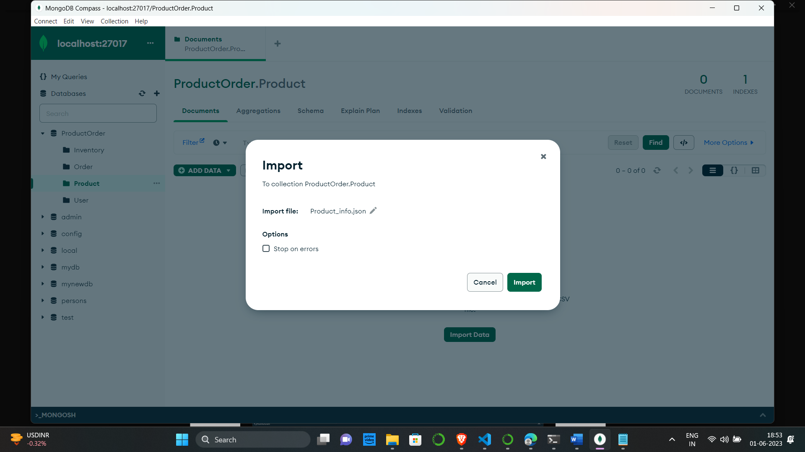

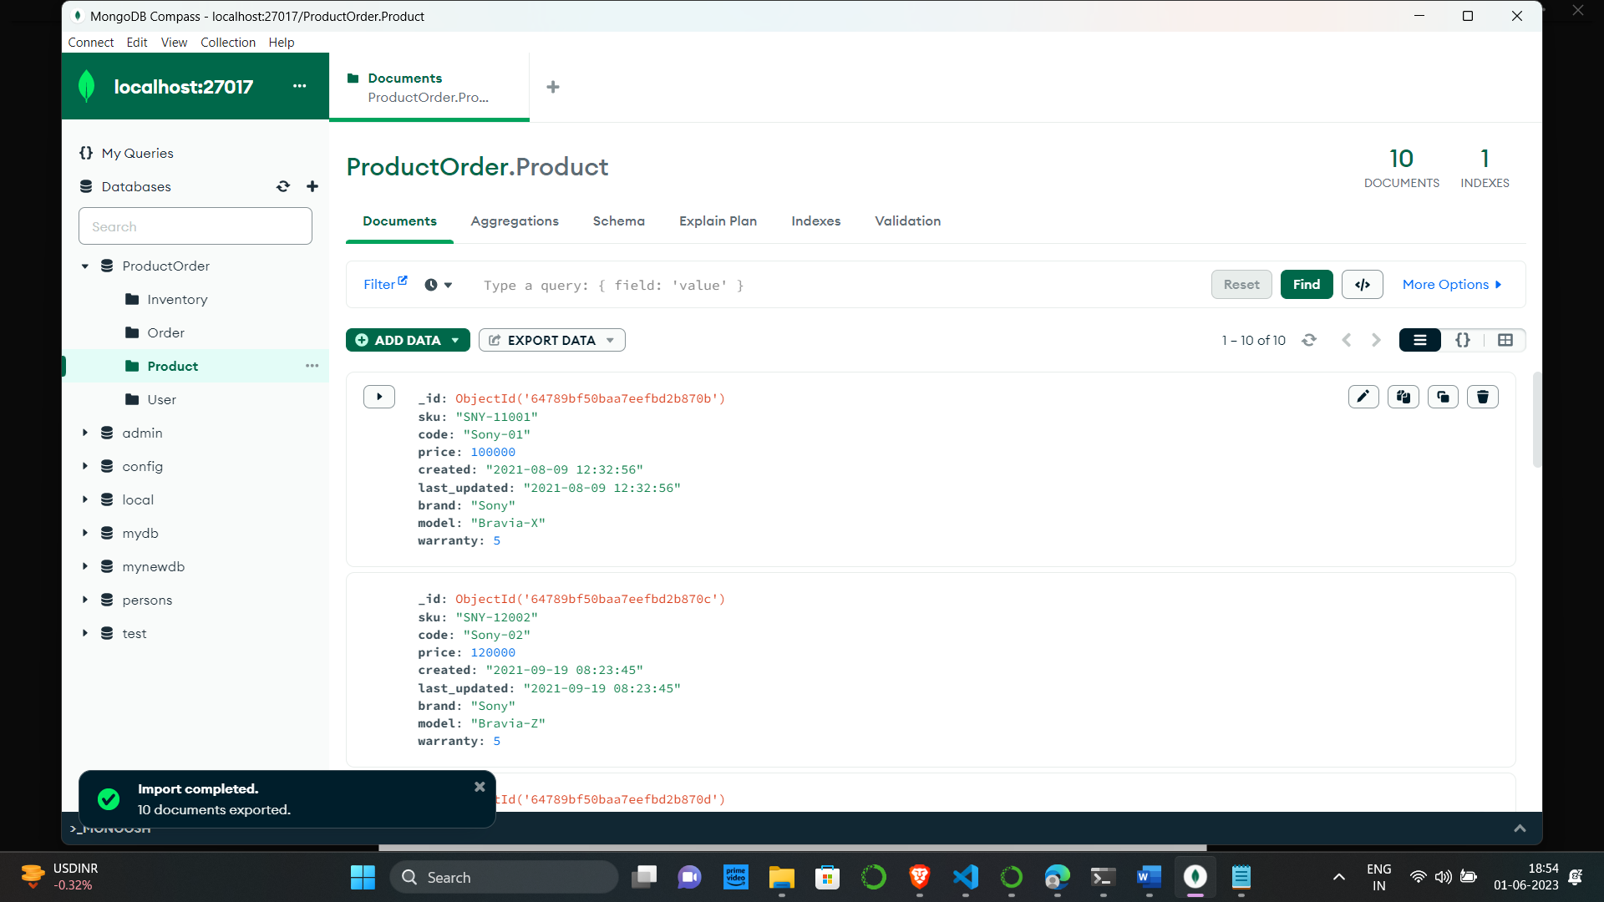

ii) Add "Inventory_info.json" file into "Inventory" collection.

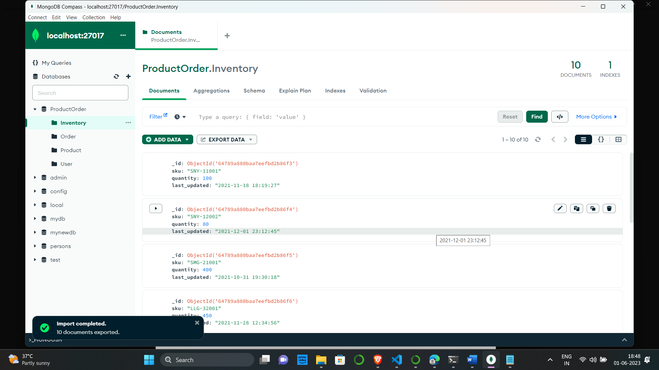

iii) Add "User_info.json" file into the "User" collection.

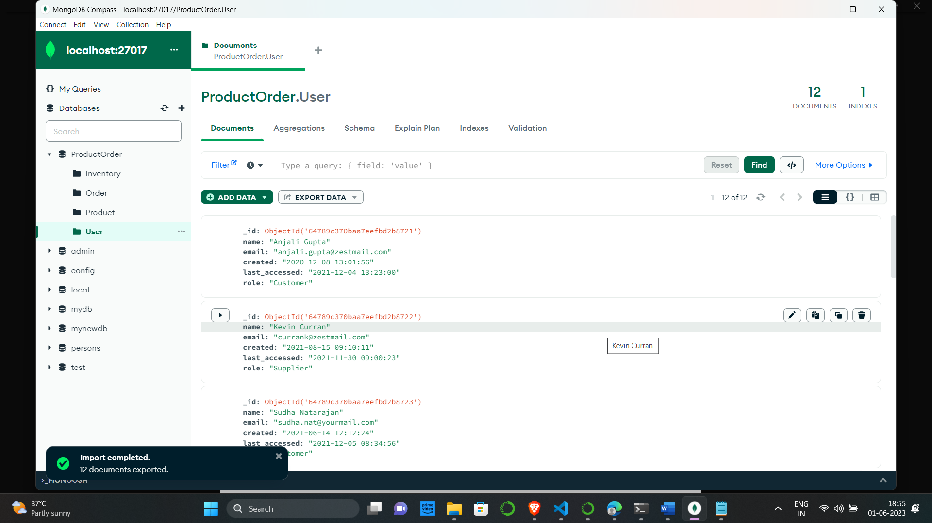

iv) Add "Order_info.json" file into "Order" collection.

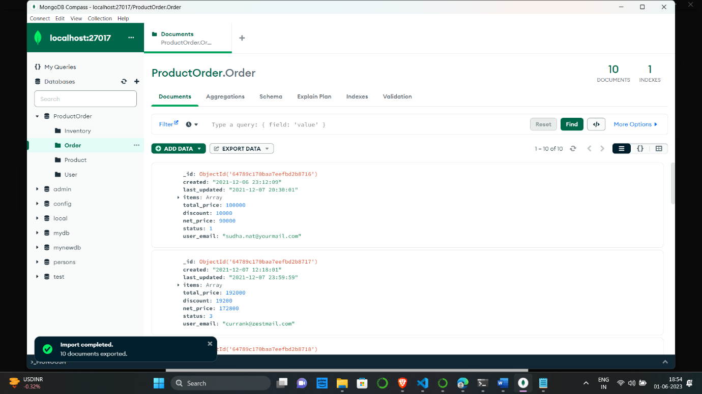

1. Display the first 5 rows of product, inventory, user, and order collection.

First 5 rows of Product

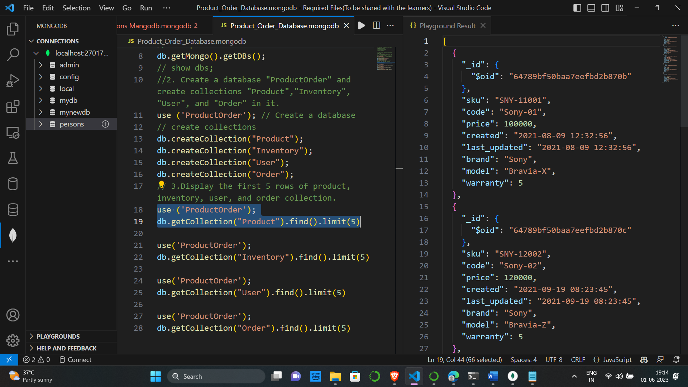

First 5 rows of Inventory

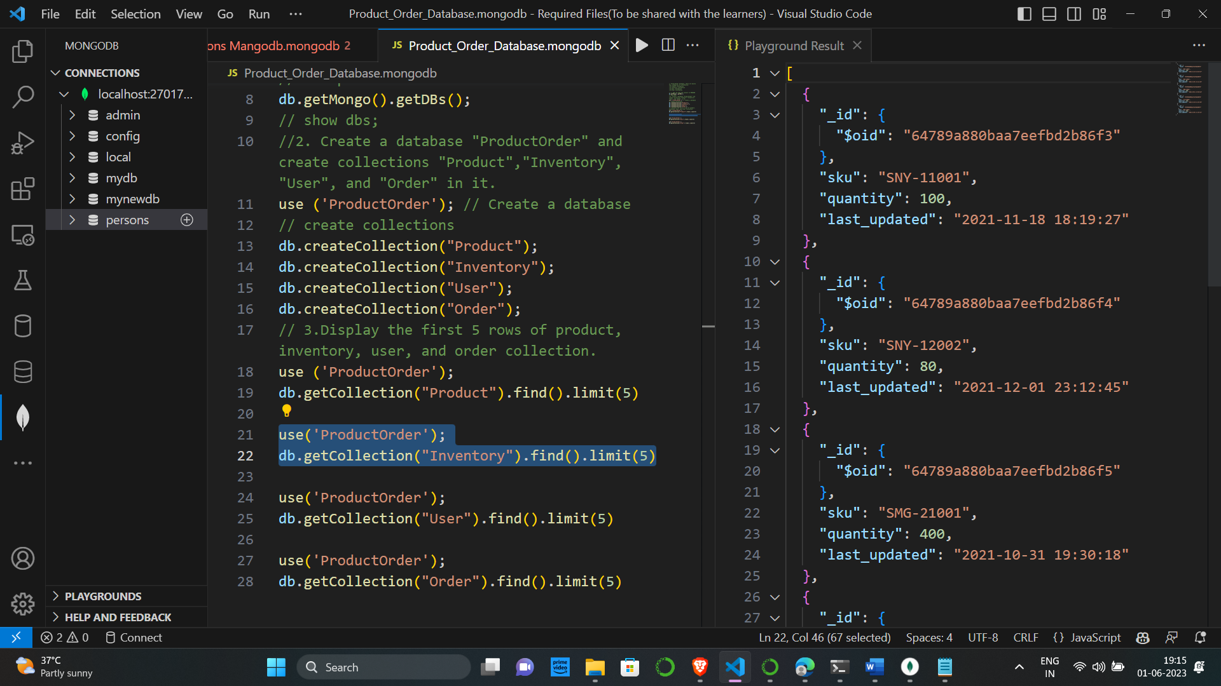

First 5 rows of User

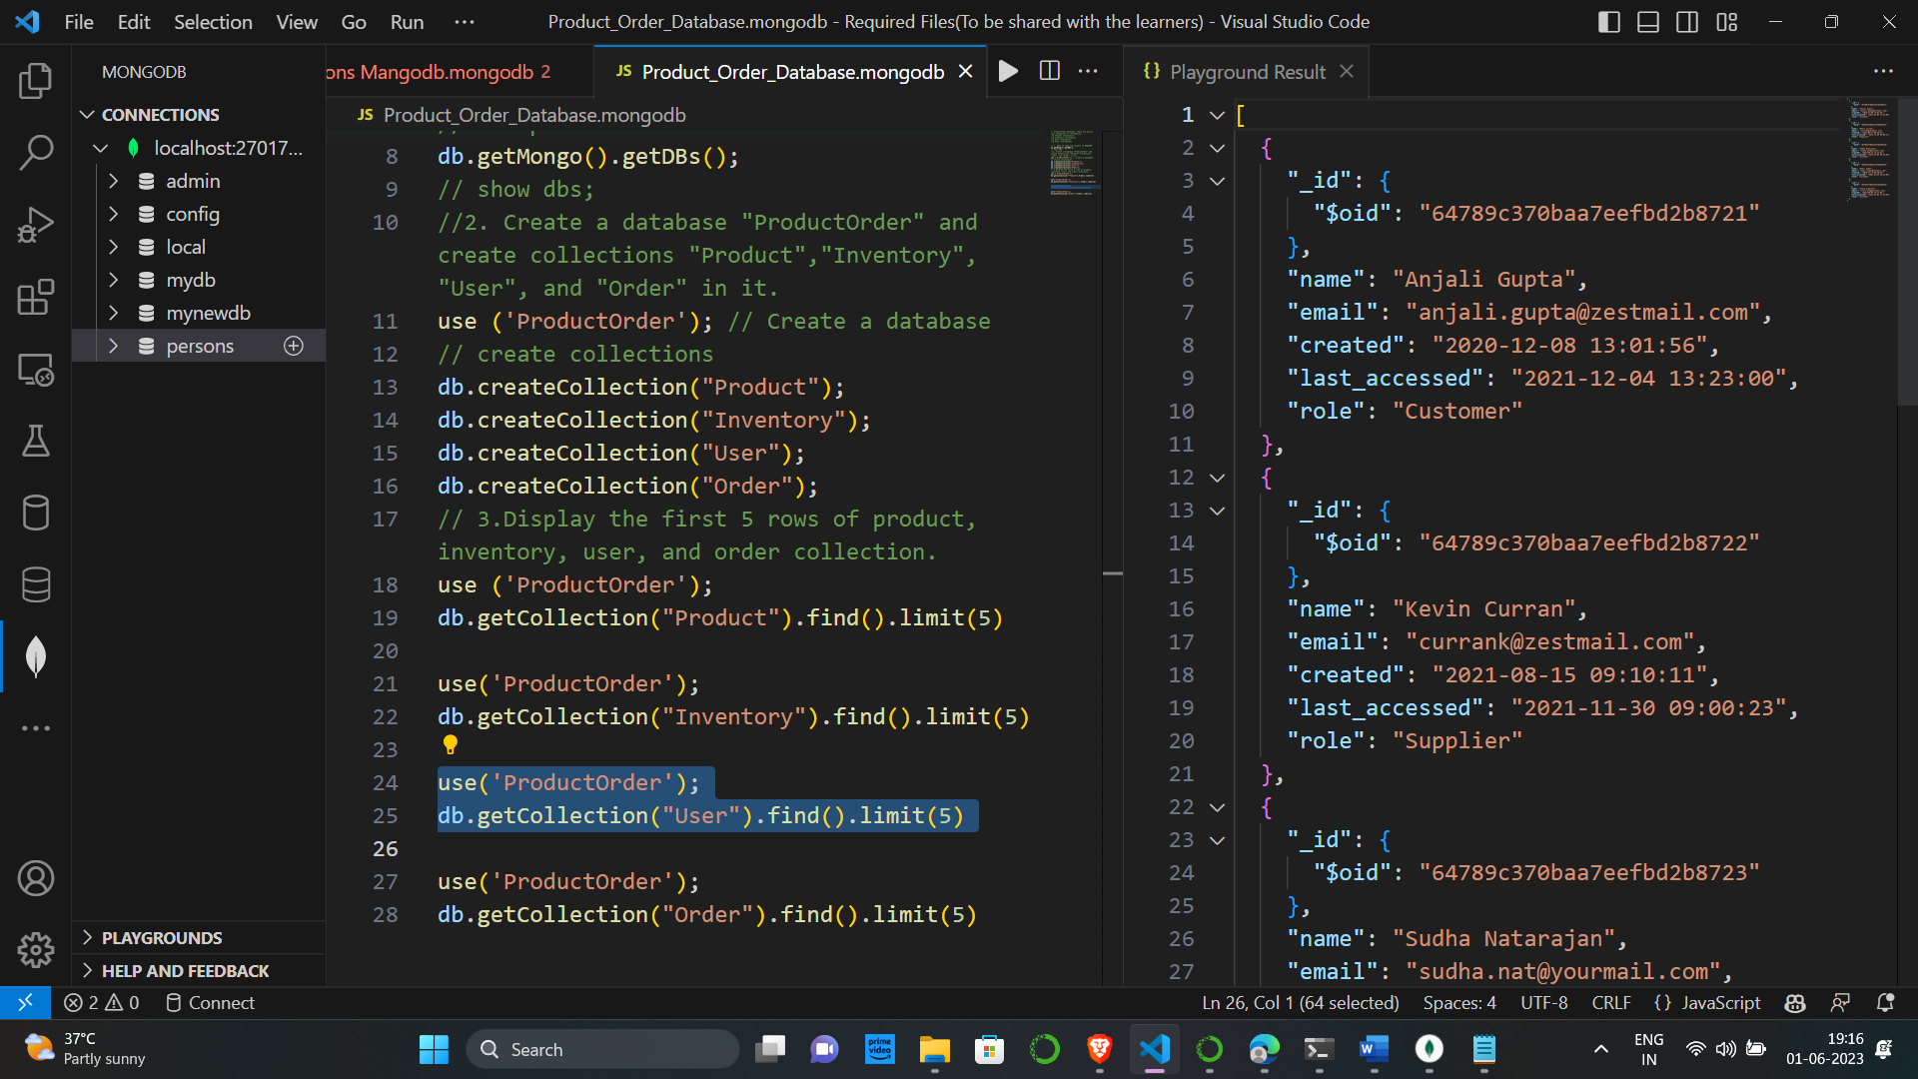

First 5 rows of Order

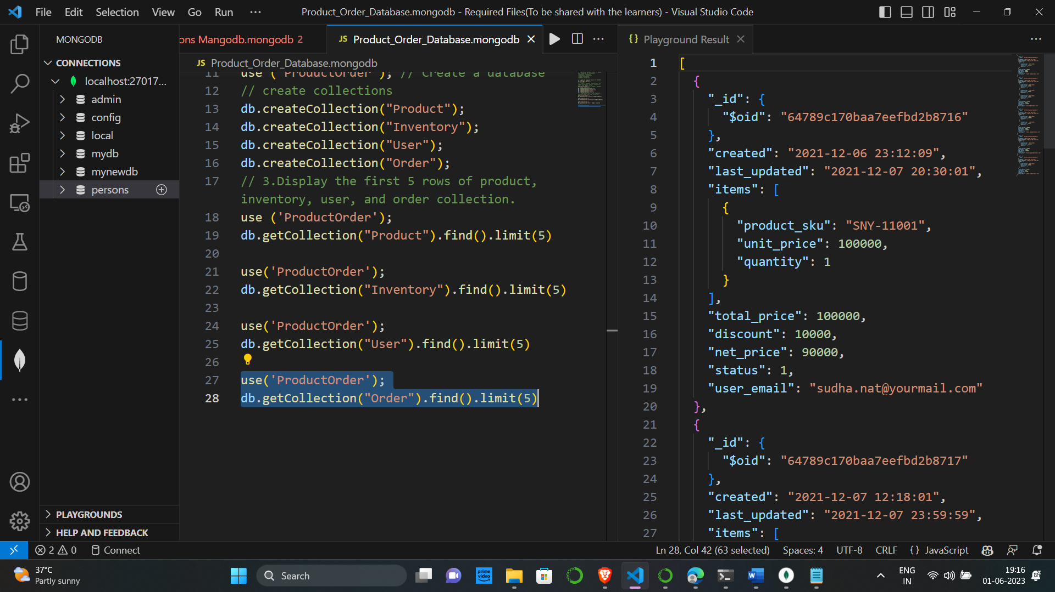

5. Display the Unique Brand and Model names from the Product collection.

Unique Brand Names

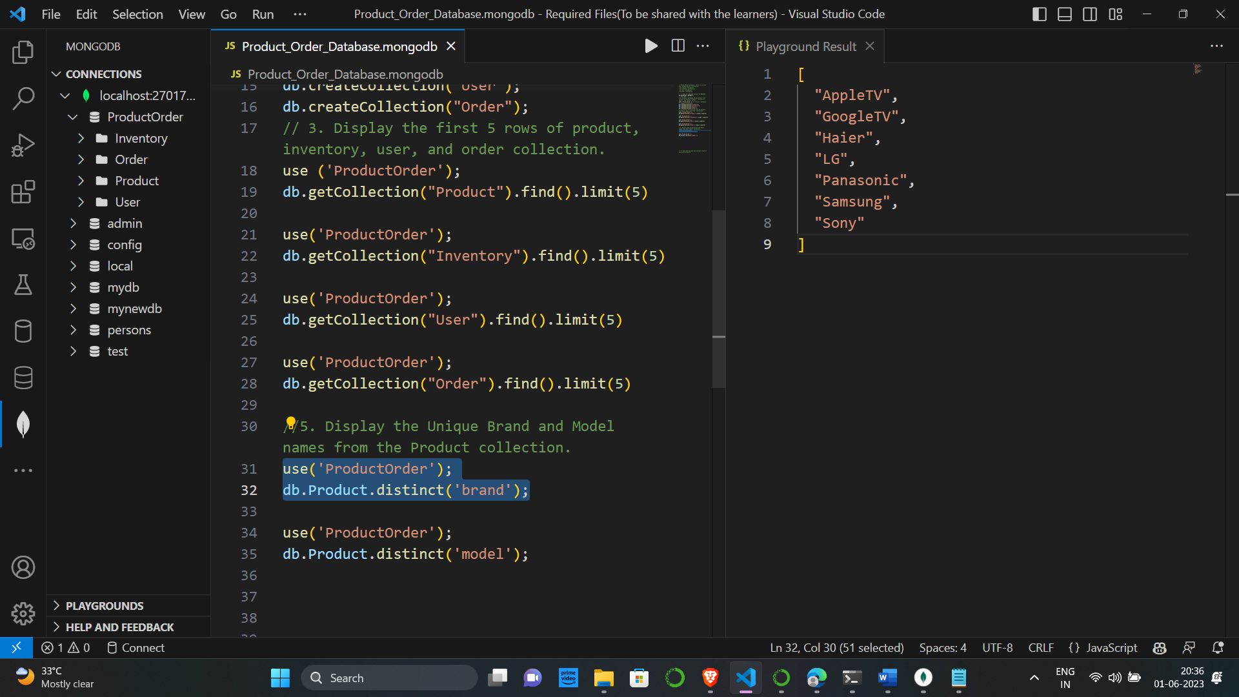

Unique Model Names

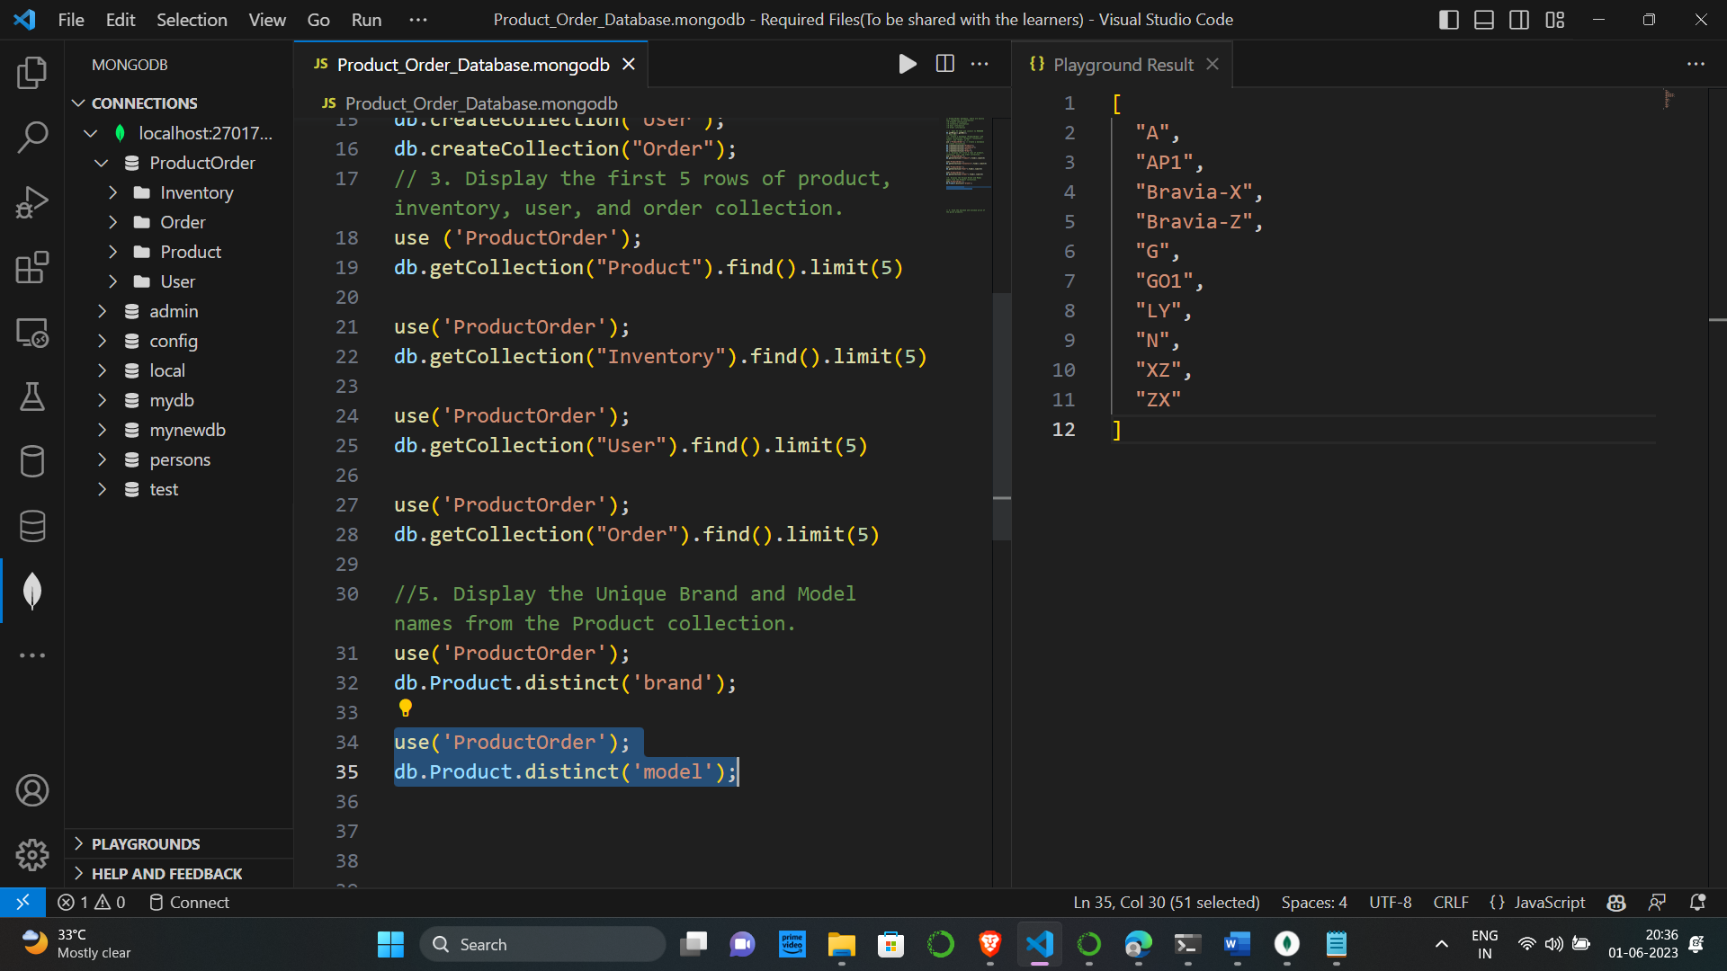

6. Find the maximum and minimum price of the given products.

Maximum Price

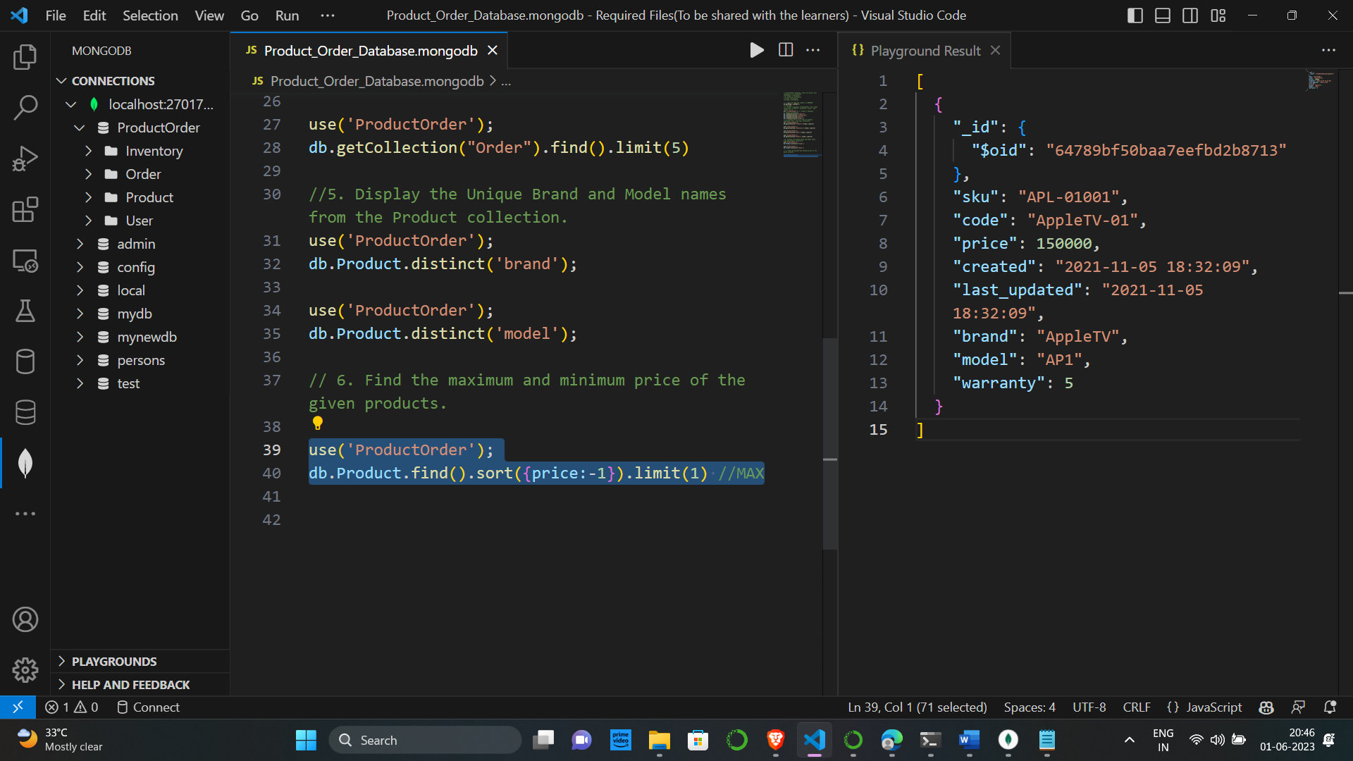

Minimum Price

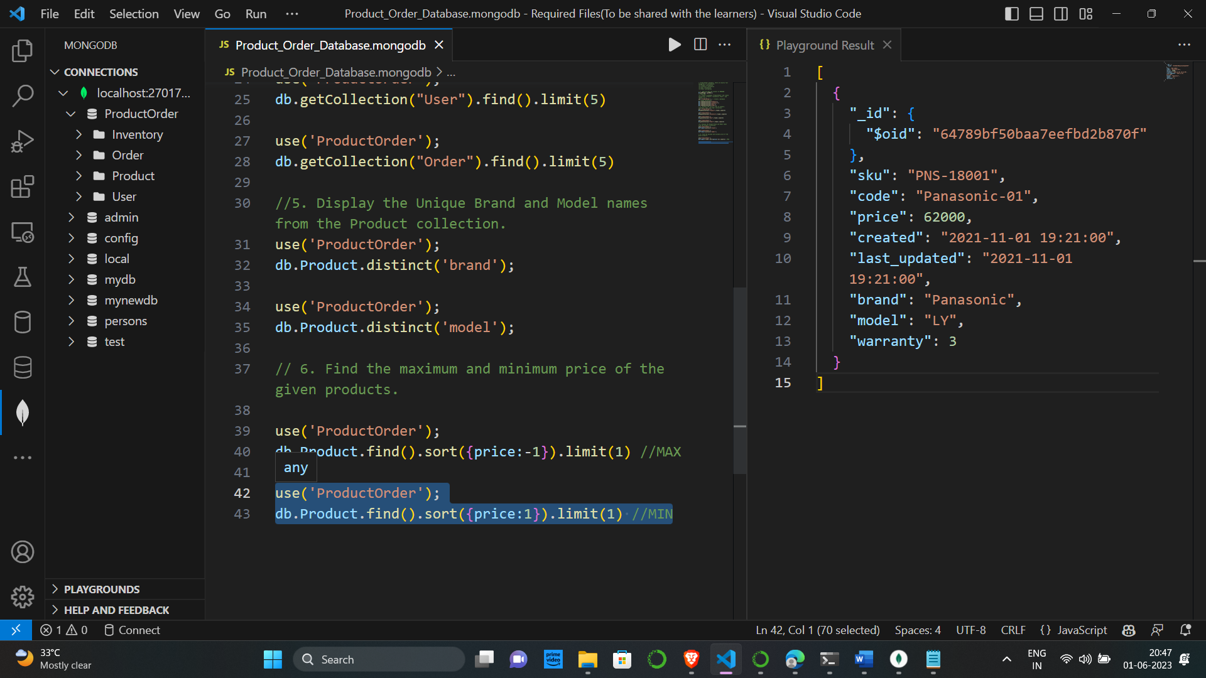

7. Display the quantity and last_updated date and time for sku "SNY-11001".

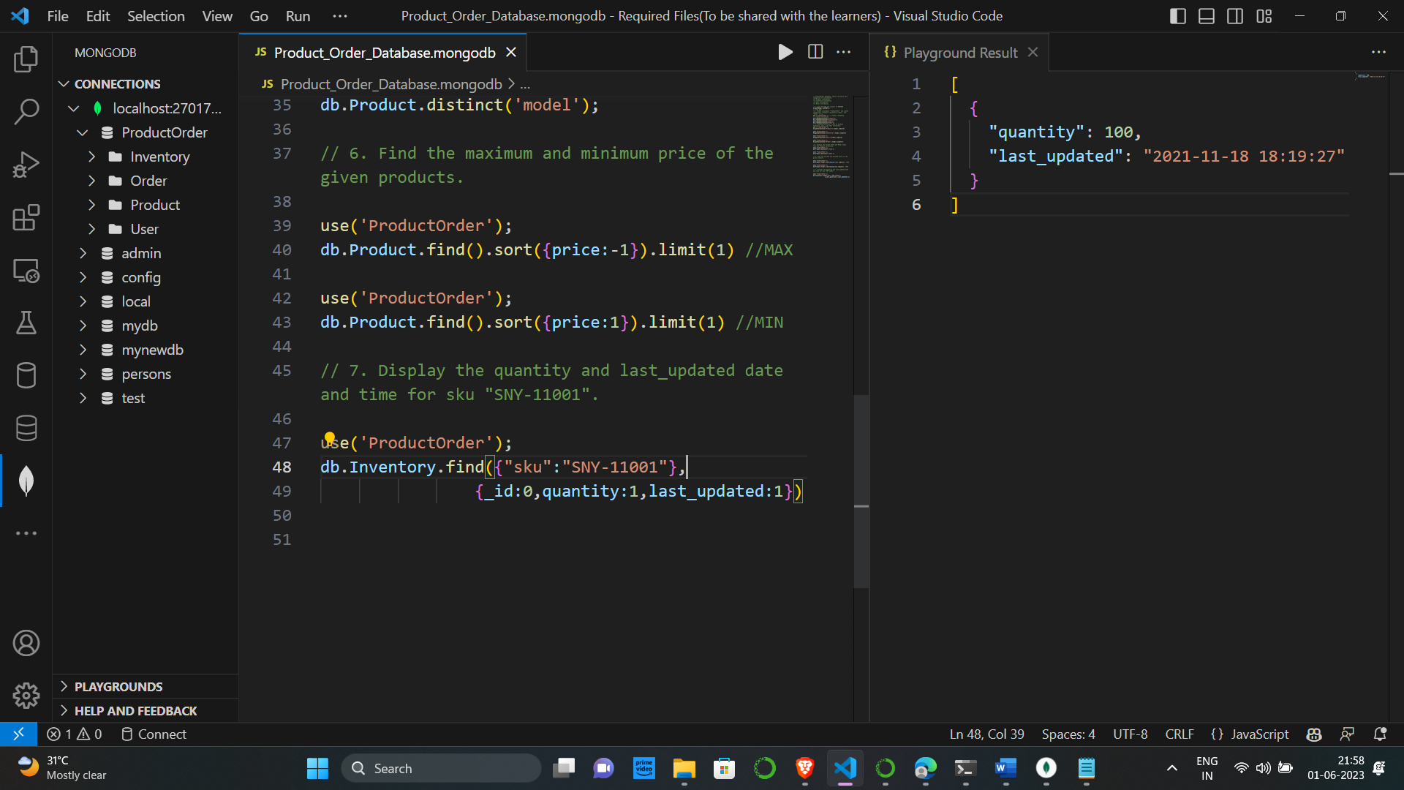

8. List down the count of the total number of users whose role is identified as 'Supplier' from User collection

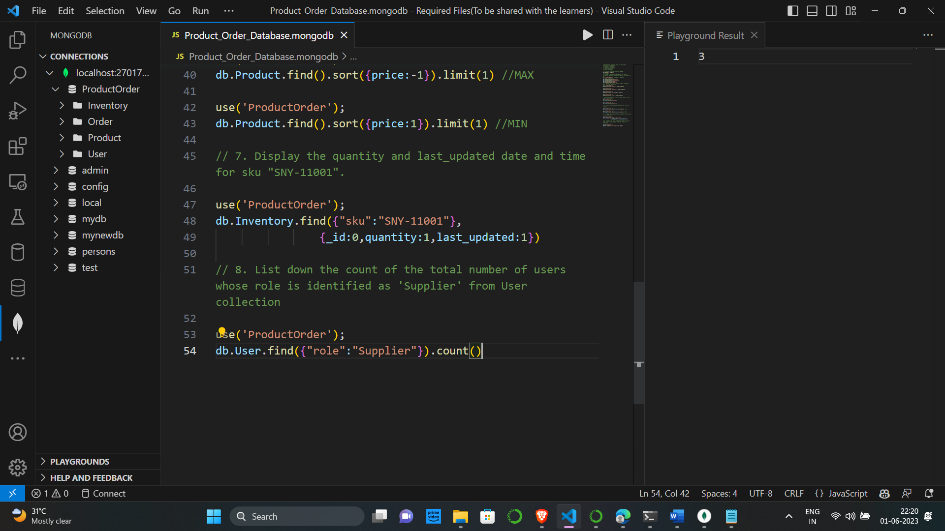

9. Display 'sku', 'code', 'price', 'brand' and 'warranty' information for the model 'Bravia-X'

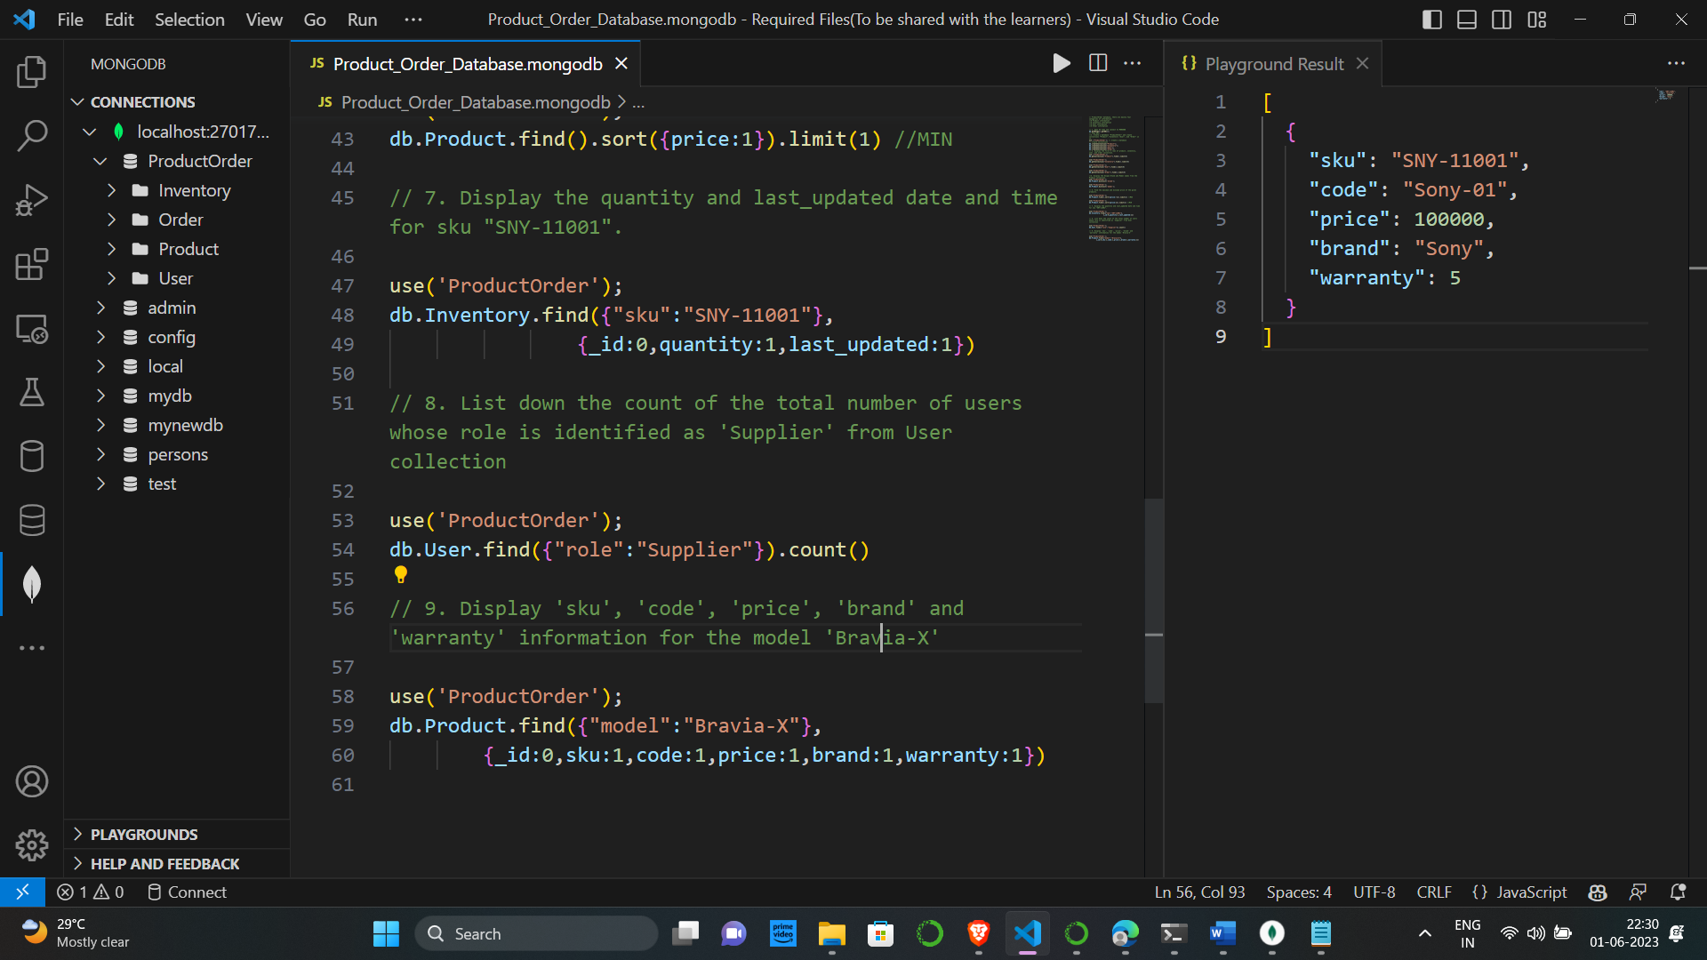

10. Find all the information of Sony products which have an Price greater than 1 lakh

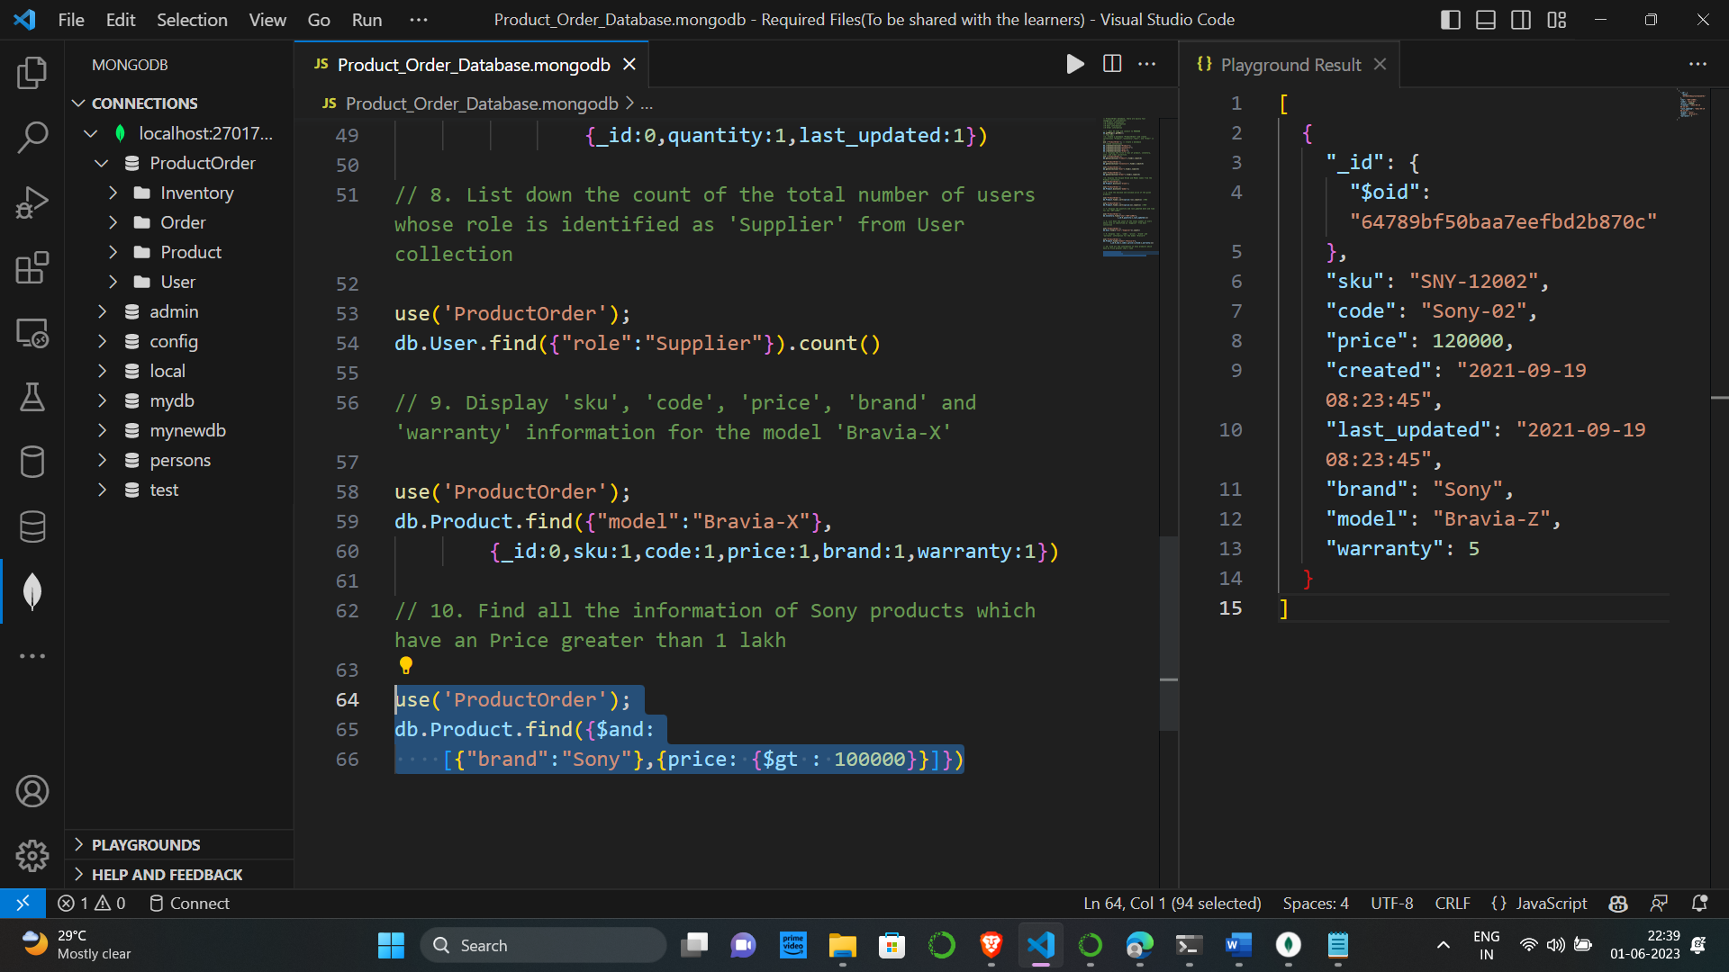

11. Find the total no of products by each Brand and sort them in descending order.

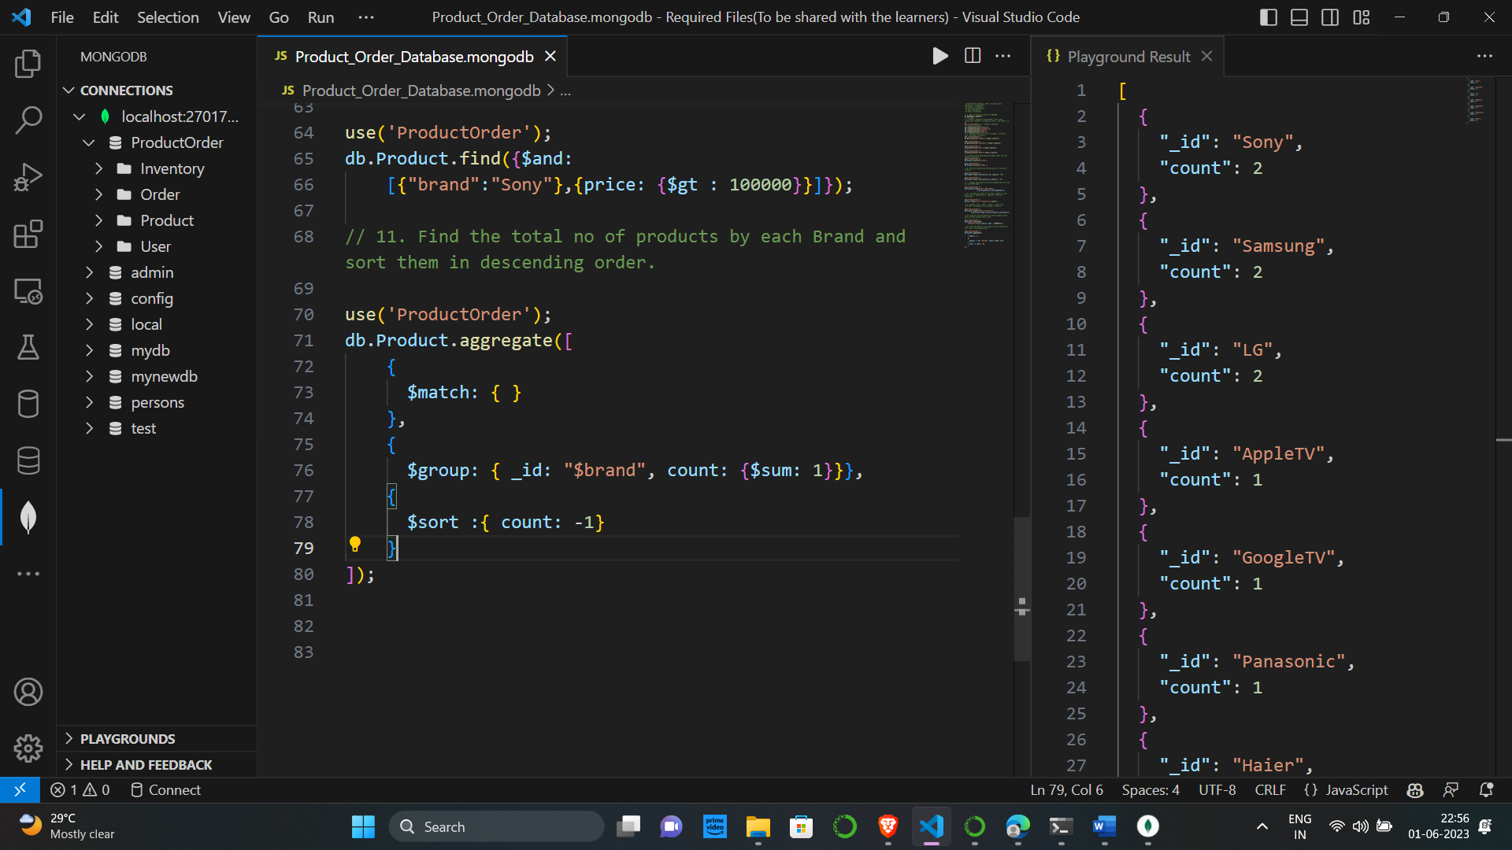

12. Find the total no of users by each role, sort them is descending order and save the results in the temporary collection

